1)Write a select command that produce the order number, amount,and date for all rowa in the orders table.
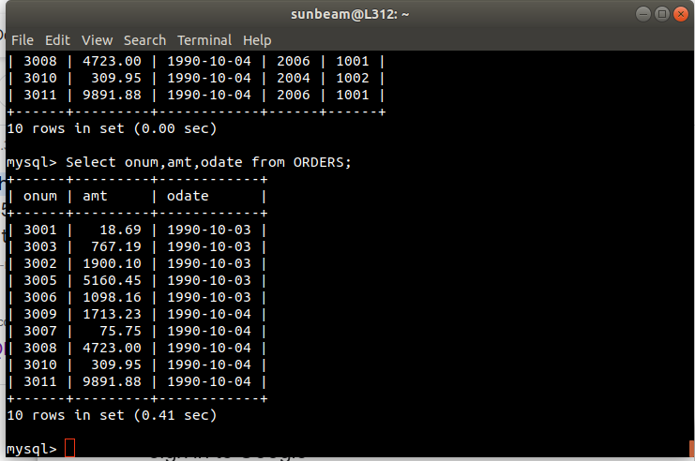

2)Write a query that produce all rows from the customer table for which the salespersons number is 1001.
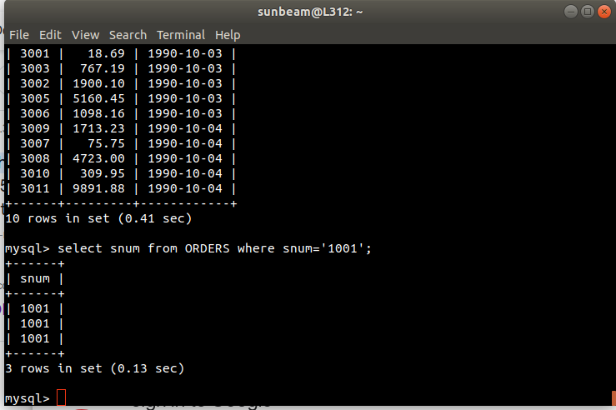

3)Write a query that display the Salespeople table with the column in the following order: city,sname,snum,comm.

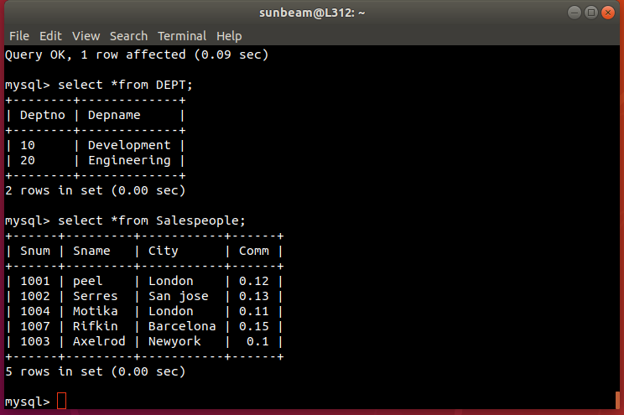

4)Write a select command that produce the rating followed by the name each customer in San jose?
